Dear Kenwilliams,
Thank you for your kind words. We will make sure to share the relevant reports and updates with Girls Not Brides members.
I would also like to share good news. You may remember submitting stories for consideration in a Girls Not Brides exhibit on child marriage, developed in partnership with the Government of Canada.
I am happy to let you know that the story was accepted! “Girls’ Voices: Speaking Out Against Child Marriage” was shown two weeks ago at the African Girls’ Summit in Lusaka, Zambia, and at the Women’s Forum during the Commonwealth Heads of Government Meeting in Malta.
I'm attaching photos of the exhibit in Zambia. If at all possible, we encourage you to share it with Zinenani so that she knows how her image and story have been used.
As you can see, your logo was included beneath the story. A panel thanking Girls Not Brides members at the end of the exhibit also features your logo, as well as a short bio of your organisation.
Thank you so much for submitting this fantastic story. I hope it helps to bring attention to your work on child marriage and the girls that you support.
With best wishes,
Sophie
Sophie Drouet
Digital & Content Editor | Girls Not Brides: The Global Partnership to End Child Marriage
Sophie.Drouet@GirlsNotBrides.org | Tel: +44(0)2037255869 | Mobile: +44(0)7909254491
www.GirlsNotBrides.org | Twitter: @GirlsNotBrides | www.Facebook.com/GirlsNotBrides
-----Original Message-----
From: african network for the protection [mailto:anppcanmalawichapter@yahoo.com]
Sent: 30 November 2015 16:50
Dear Mr. Kenwilliams Mhango,
I hope all is well.
I am very excited that you will be the representative for MANEPO on SARAN. As network development and partnership manager, I would like to come to Malawi and learn more about MANEPO. The visit will be about 3 - 4 days and ideally occur in a week when MANEPO is holding a meeting for it's members so that i can observe it. Will that be suitable for you?
Together with you and any other relevant network members, I would do assist you in doing a self-assessment for MANEPO in order to see which capacities of the network is strong and which need further development. This visit will help us determine together who HelpAge/Saran and MANEPO will collaborate to assist in addressing the needs and rights of the elderly. Ideally i would also like to spend a day meeting some members/organisations that are part of MANEPO so that i can collect class studies.
I will give you details about what to expect at a later stage. But right now I am wondering if you and the relevant members of FTI will be available for the visit on any of the possible dates:
7 - 10 March or
14 - 17 March or
21 - 24 March
Please let me know as soon as possible if any of these weeks are suitable for you.

Added Children's Peace Prize. Press backspace to remove.
Skip to content
Using Gmail with screen readers
Top of Form
Bottom of Form

nominees' changemaking stories 2016
Inbox | x

nominations@childrenspeaceprize.org |  |  | Sep 20 (2 days ago)

to me

Dear Kenwilliams Mhango,

The Expert Committee is still assessing the candidatures for the International Children’s Peace Prize. The three finalists for the International Children’s Peace Prize 2016 will be announced on 15th November 2016. We will inform you on 11th November about your candidate.

In the meantime, we like to give you an update on sharing Maggie’s story online.

This year KidsRights received a record number of 120 nominations of remarkable children worldwide. We will celebrate their inspiring stories of hope with a global online campaign #ChildrensPeacePrize. In the coming weeks the powerful messages of all the nominees of the International Children’s Peace Prize will be posted on our website. You can find the stories of the nominees www.kidsrights.org/nominees

As no authorization was given to use the photo/story of Maggie, the story of your candidate isn’t posted on the website.

You can help spread the message!

You can use the publication of Maggie’s story to further promote the amazing actions locally thereby inspiring many children and adults with the stories of change. Please note that this may generate the attention of media and you will have to be prepared to coordinate this.

Suggestions:

1. Please follow KidsRights on Facebook and Twitter:
2. Share KidsRights’ announcement of the launch of the campaign on Facebook or Twitter on 20th September 2016.
3. Attached is a certificate recognizing Maggie’s nomination for the International Children’s Peace Prize 2016. You could make a picture of Maggie with the certificate and share this online. If you would like to receive a hard copy of the certificate, please send us the postal address to be able mail the certificate.
4. Ask important influencers and ambassadors in your network to share Maggie’s story on their Facebook and Twitter, using #ChildrensPeacePrize
If you have further requirements or questions, please feel free to contact us. We will be glad to assist you in any way we can.
Warm regards,

Ellen Vroonhof
Programme Manager
T +31 (0)20 343 5312
E ellen@kidsrights.org
P.O. Box 283 – AZ1425, 1000 EA Amsterdam
Rembrandtweg 6, 1181 GW Amstelveen
www.kidsrights.org
www.childrenspeaceprize.org
www.kidsrightsindex.org

Attachments area
Anppcanmalawichapter Kenwilliams |  |  | Sep 21 (1 day ago)
  From: Anppcanmalawichapter Kenwilliams <anppcanmalawichapter@gmail.com> Date:...
 | 1:50 PM (3 hours ago)
  nominations@childrenspeaceprize.org

to me

Dear Kenwilliams Mhango,

Thank you for your reply! We will now consider your e-mail as an authorization for Maggie’s story to be posted online and we will make sure that Maggie’s story will be posted on our website.
We will let you know when Maggies’s story will be posted on our website!

Kind regards,

Annelot Reehoorn
Intern Programmes & Advocacy
T +31 (0)20 343 53 13
E annelot@kidsrights.org
Postbus 283 – AZ1425, 1000 EA Amsterdam
Rembrandtweg 6, 1181 GW Amstelveen
www.kidsrights.org
Please also follow The KidsRights Youngsters:
www.kidsrightsyoungsters.org

Van: Anppcanmalawichapter Kenwilliams [mailto:anppcanmalawichapter@gmail.com]
Verzonden: dinsdag 20 september 2016 17:44
Aan: Children's Peace Prize
Onderwerp: Re: nominees' changemaking stories 2016
 | 5:00 PM (0 minutes ago)
  Anppcanmalawichapter Kenwilliams <anppcanmalawichapter@gmail.com>

to Children's  Hie Annelot Reehoorn  Intern Programmes & Advocacy  Hope you are well, thank you so much for your understanding.  We look forward to see our nominee among the lest for the rest.  Have a good day.  Kenwilliams Mhango  2.39 GB (15%) of 15 GB used  Manage  Terms - Privacy  Last account activity: 2 hours ago  Details |  | People (2)
   | Click here to Reply or Forward
  Children's Peace Prize

Show details
Top of Form

About Us | Press | Contact | Newsletter

- Home
- What we do
- What you can do
- News

Nominees
- The KidsRights Youngsters
- Changemakers
- Projects
- Research
- For Schools

KidsRights - What we do - International Childrens Peace Prize nominees
The 2016 International Children's Peace Prize Nominees
KidsRights strives for a world where all children have access to their rights. Worldwide children act to improve their rights and demonstrate that change is possible. Their initiatives are sometimes small but when you give these children a voice and support, they have great impact. KidsRights gives them a global platform to tell their story and inspire us all to move the world.
On December 2nd KidsRights will award the International Children’s Peace Prize 2016. This prize is awarded annually to a child who fights courageously for children’s rights. The 120 nominees of 2016 demonstrate that children are changemakers. With your support we can help more children, so they can take action for their ideas and dreams.
“Give a voice to the voiceless!”
- Desmond Tutu, Nobel Peace Laureate and patron of KidsRights

Give a voice to children
€ 10,00€ 20,00 € 30,00 Other
Donate today

Share this page!
search
Filter on:

Bottom of Form
• •
Top of Form

- 
Jawad
Afghanistan
Issue:
Peace
View profile
- 
Rohullah
Afghanistan
Issue:
Education
View profile
- 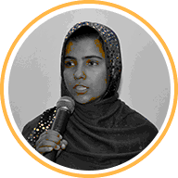
Sapna
Afghanistan
Issue:
Education, Gender Equality
View profile
- 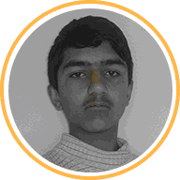
Ehsan
Afghanistan
Issue:
Peace, Education
View profile
- 
Grace
Australia
Issue:
Poverty, Child Participation
View profile
- 
Zarina
Azerbaijan
Issue:
Child Participation
View profile
- 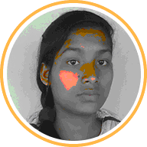
Itee
Bangladesh
Issue:
Child Marriage, Gender Equality, Education
View profile
- 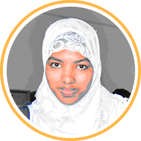
Shukhi
Bangladesh
Issue:
Street Children, Violence, Child Marriage
View profile
- 
Shirin
Bangladesh
Issue:
Child Marriage, Education, Violence
View profile
- 
Sujon
Bangladesh
Issue:
Child Marriage, Violence, Child Labor
View profile
- 
David
Bosnia and Herzegovina
Issue:
Child Participation
View profile
- 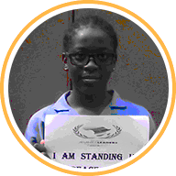
Divina
Cameroon
Issue:
Violence, Education, Peace
View profile
- 
Achuo
Cameroon
Issue:
Street Children, Education, Violence
View profile
- 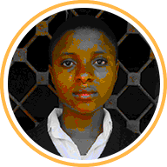
Sharon
Cameroon
Issue:
Education, Health, Gender Equality
View profile
- 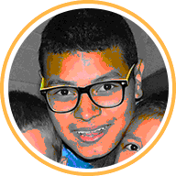
Davison
Colombia
Issue:
Violence, Child Participation, Peace
View profile
- 
Diego
Colombia
Issue:
Violence, Peace
View profile
- 
Fiorella
Colombia
Issue:
Peace
View profile
- 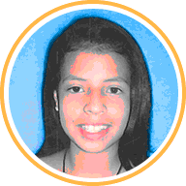
Luisa
Colombia
Issue:
Child Participation, Violence
View profile
- 
Santiago
Colombia
Issue:
Peace, Education
View profile
- 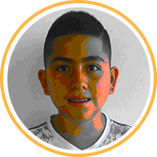
Santiago
Colombia
Issue:
Peace, Education
View profile
- 
Maria Jose
Costa Rica
Issue:
Poverty, Child Participation
View profile
- 
Sofia
Costa Rica
Issue:
Health
View profile
- 
Stephannie
Costa Rica
Issue:
Discrimination, Gender Equality
View profile
- 
Jamilah
Croatia
Issue:
Child Participation
View profile
Page 1 of 4FirstPrevious[1]234NextLast

KidsRights is proud of our cooperation with
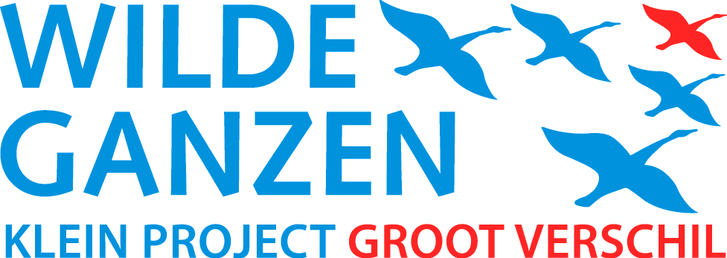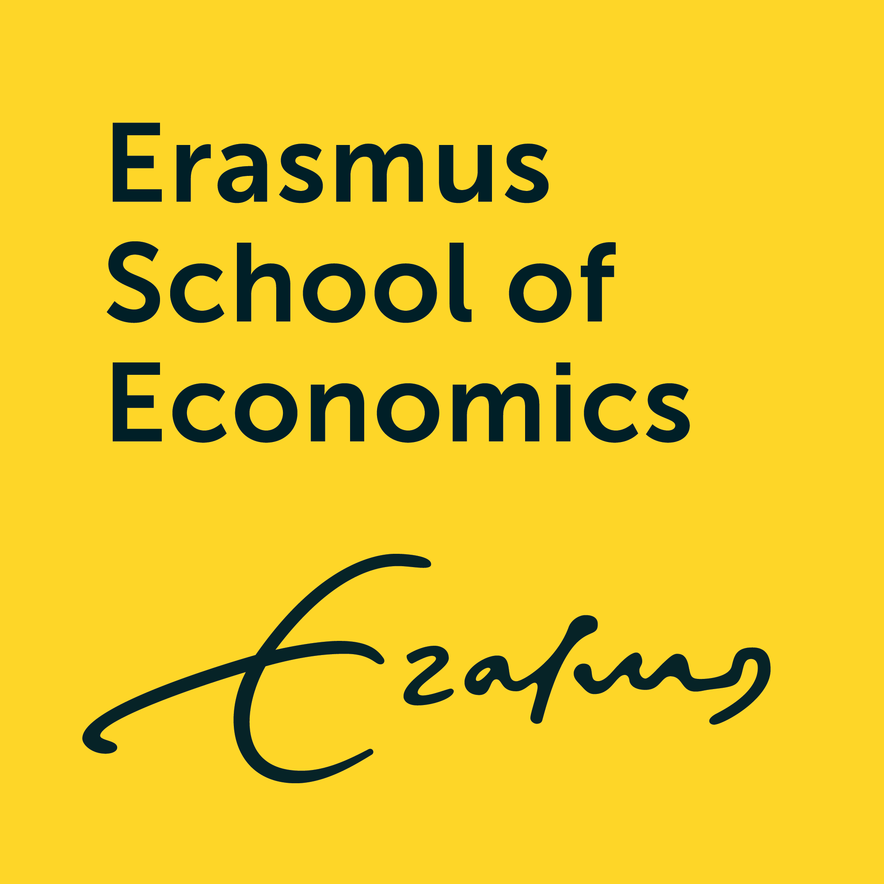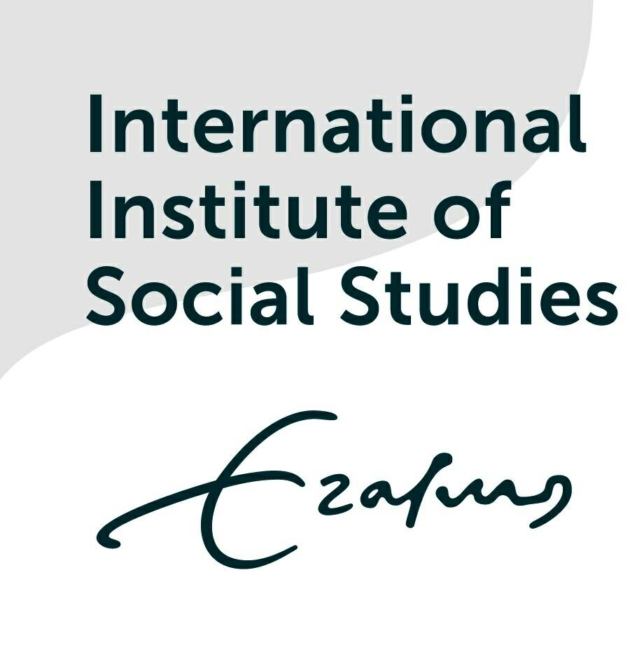

What does KidsRights do?
- KidsRights Index
- International Children's Peace Prize
- KidsRights Youngsters
- Projects

What you can do
- Become a donor

Contact KidsRights
- Contactform
- Call us on +3120 - 343 5313
- Follow us on Facebook
- Follow us on Twitter
- Follow us on YouTube
- Privacy
- Disclaimer
- Site by ValueProof
- Login

Bottom of Form

