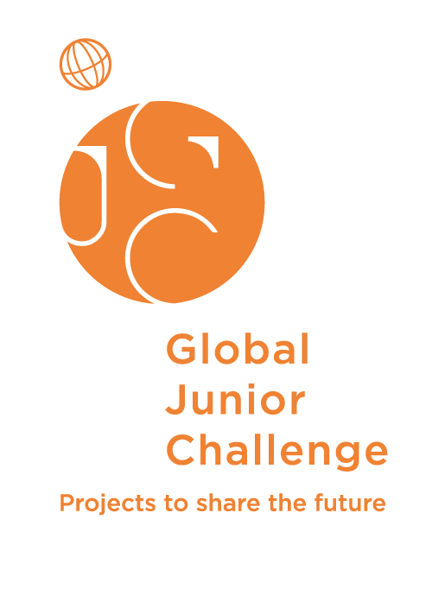

GLOBAL JUNIOR CHALLENGE 2017
ENTRY FORM

Fill in the form using capital letters.

The form should be sent at the e-mail address info@gjc.it /
f.castagnini@mondodigitale.org / d.cavallo@mondodigitale.org
or by post or fax within the 20 of September 2017 to:

GLOBAL JUNIOR CHALLENGE
Fondazione Mondo Digitale
Via del Quadraro, 102
00174 Roma
ITALY

Fax: +39-06-42000442

PROJECT NAME:

Emergency medical care during disasters using Information technology

- Please provide us with a few keywords (max 255 characters) which best describe your project. Separate each one with a space and do not use [enter].
These keywords will be used in the project database and search engine of the GJC website. (Avoid general terms such as "Internet" and "Web")

Last year, Peru and other countries around the Pacific Ocean have been affected by the phenomenon known as El Nino, a rise in sea temperatures that increases evaporation and brings about heavy rains. In 1998 floods in Peru were also linked to El Nino, which was particularly strong that year.
Telehealth in Peru is becoming a reality, as in other countries in the region and the world, favoring access to health services at all levels of care, providing technological benefits, allowing a coordinated and immediate response of care, establishing a quick and accurate diagnosis in case of an emergency.

That is why, from MINSA (Ministry of Health of Peru), under the direction of the General Directorate of Telehealth has begun with telecapacitations at the national level. Focusing efforts on training health personnel in the regions affected by the Coastal Child.

In order to confront health emergencies due to the rains and floods in our country, the Health, Referral and Emergency Department of the Ministry of Health has been conducting telecapacitations nationwide.

The use of educational technology to make a difference provides integrity correctly in the hospitals using the corresponding application in different areas. Specialists are working to train health personnel in areas affected by disasters.
Tele-trainings for health personnel at the national level will continue and priority specialties are: infectious diseases, mental health, chronic diseases, telehealth and electronic clinical records.

- COUNTRY ( City / Region):
PERU

- COMPANY/ORGANIZATION/INSTITUTE PRESENTING THE PROJECT:
UPCH IMT AVH

- TYPE OF ORGANIZATION:
- School
- University X
- Public institution
- Private institution
- Company
- Association
- Research center
- Cultural Institution (foundations, museums, galleries, etc…)
- Other

- PROJECT COORDINATOR (our contact for all further information and confirmation of participation):

Name and Surname: ________LADY MURRUGARRA___________________

Address: __AV. HONORIO DELGADO 430 LIMA 31_______________________

Telephone: _____________51993470712
Fax_________________________________

E-Mail: _____lady.murrugarra@upch.pe _________________________

- WEB address:

http://imtavh.cayetano.edu.pe/en/research/groups/telesalud-research-group.html

Privacy Law:
Your personal data will be treated by the Fondazione Mondo Digitale with headquarter in via Umbria 7, 00187 Roma, Italy, in accordance with art. 10 and 11 of the law 675/96. The responsible for the treatment is Mirta Michilli, general director of the Fondazione Mondo Digitale.
Your personal data will not be given to anybody else without your previous consent, excepting partners interested in your project for eventual contact.
At any moment you can address the Fondazione Mondo Digitale and its General Director to exercise your rights, as stated in art.13 of the law 675/96.
To participate in the Global Junior Challenge you must consent to the treatment of your personal datas.
 I do authorize the FMD to the treatment of my personal data.

8. Please select the category (only one) you submit your project:

 Up to 10 years
 Up to 15 years
 Up to 18 years
 Up to 29 years X
 Helping youth step into the job market
❑ ICT for the inclusion of migrants and refugees
❑ ICT for environmental sustainability

- DESCRIBE YOUR PROJECT IN ONE SENTENCE (to be used per identification in database)

Disaster response to mass-casualty incidents represents one of the greatest challenges to a community's emergency response system. Rescuers, field medical personnel, and regional emergency departments and hospitals must often provide care to large numbers of casualties in a setting of limited resources, inadequate communication, misinformation, damaged infrastructure, and great personal risk.

- Describe briefly (max. 2000 characters) the key aspects of your project (including how the idea was born and developed, and who is implementing the project today).

Primary care is the doorway into the Peruvian public health system. On that level of care, personal health have a main role. As such, they can benefit from telehealth initiatives that bring them closer to specialists of other levels of care. We created with Ministery of Health in all in Peru a novel system (telecapacitations) using information and communication technology (ICT) to respond to a sudden shortage, and tested the system to determine whether it would compensate for a shortage after “Niño Costero”.

After introducing the system to train health personnel, the probability of learning in emergencies when there are no specialists increased. Therefore, the system of telecapacitations is helping considerably and also to create the telehealth units in their hospitals, health centers, medical posts among others.

11. HOW LONG HAS YOUR PROJECT BEEN RUNNING? (Please note that to be eligible projects must be up and running since 31st December 2016 or earlier)
 No
 Yes, since when? 2016

12. OBJECTIVES AND INNOVATIVE ASPECTS

- What opportunities/problems does the project address and what are its specific objectives? How and with which instruments does the project try to achieve its specific objectives (max 2000 characters)?

Telecapacitations is the system necessary for the personal of health without the specialist in disasters zone. After introducing the system, probability of personal of health increased. This the system may contribute to improvement in the ability to respond to sudden excessive patient needs in multiple emergencie.

13. RESULTS

- Describe the results achieved by your project How do you measure (parameters) these? (max 2000 characters).

Each week we have differentes issues for personal health. In differents regions are create the Telehealth Unit effectively. The Telecapacitations was designed to improve the response for the emergencies and contact very fast with the specialists.

The ICT help us for the disasters and very fast attention for the patients and education.

The network social (facebook, twitter, messenger), help them for the food and accommodation..

- How many users interact with your project monthly and what are the preferred forms of interaction (max 500 characters)?

In particular, next-generation wireless Internet and geopositioning technologies may have the greatest impact on improving communications, information management, and overall disaster response and emergency medical care.

ICT to promote the reduction of poverty and increase social inclusion in developing countries.

14. SUSTAINABILITY

- What is the duration of your project (from beginning to end)?
 Less than 1 year
 From 1 to 3 years X
 From 3 to 6 years
 More than 6 years

We still work without funds

- What is the approximate total budget for your project (in USD)?
 Less than 10.000 USD X
 From 10.001 to 30.000 USD
 From 30.001 to 75.000 USD
 From 75.001 to 500.000 USD
 More than 500.000 USD

- What is the source of funding for your project?
 Sale of products or services
 Grants
 Fee
 Advertising
 Commission
 Sponsorships
 Other, please specify Awards such as GJC etc

X From work.

- Is your project economically self sufficient now?
 Yes, since when?
 No, when is it expected to become self-sufficient? When it gets financial support. X

15. TRANSFERABILITY
- Has your project been replicated/adapted elsewhere?
 No
 Yes , Where? By whom? X PERU AND MINISTERY OF HEALTH

- What lessons can others learn from your project?

These technologies have applications in terms of enhancing mass-casualty field care, provider safety, field incident command, resource management, informatics support, and regional emergency department and hospital care of disaster victims.

 We are available to help others to start or work on similar projects.
Yes,

16. BACKGROUND INFORMATION (optional)

- Barriers/Solutions: What were the major barriers or challenges to the implementation and acceptance of your product/process/service and what solutions (if any) did you apply to tackle these problems or barriers?

- Future plans and wish list: Briefly describe future plans or ambitions for your project. What would you require to make them true?

On september we have the Hackaton in Health with 5 areas priorities. After Hackaton we will create more applications to help thousands persons in the take care of the health.( https://www.youtube.com/watch?v=y3T1bK8zwyA)

